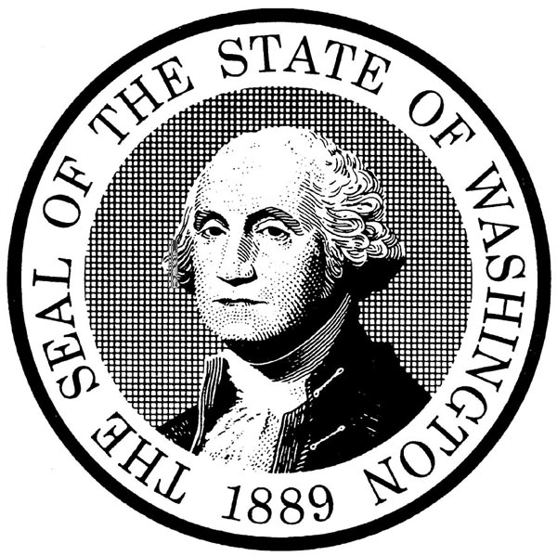
Superior Court of Washington
County of Kitsap

_______________________________,  Plaintiff(s),  v.  _______________________________,  Defendant(s). | NO. _____________________  ARBITRATION AWARD (ARBA)

The issues in arbitration having been heard on _________________________________, 20______.

I make the following award:

Twenty days after the award has been filed with the clerk, if no party has sought a trial de novo under CAR 7.1, any party on notice to all parties may present to the Ex Parte Department a judgment on the arbitration award for entry as final judgment in this case.

Was any part of this award based on the failure of a party to participate at the hearing?

Yes No (CAR 5.4)

If yes, please identify the party and explain:

DATED this __________ day of _______________, 20______.

______________________________________________
ARBITRATOR

ORIGINAL TO BE FILED WITH THE SUPERIOR COURT CLERK, KITSAP COUNTY COURTHOUSE, TOGETHER WITH PROOF OF SERVICE ON THE PARTIES. A COPY MUST ALSO BE SENT TO THE ARBITRATION DEPARTMENT.

